Spring REST Hands-On Exercises Documentation

Exercise 1: Create a Spring Web Project using Maven
Topic: Initializing the Spring Boot application structure with the required dependencies .

Full pom.xml:
XML
<?xml version="1.0" encoding="UTF-8"?><project xmlns="http://maven.apache.org/POM/4.0.0" xmlns:xsi="http://www.w3.org/2001/XMLSchema-instance"
xsi:schemaLocation="http://maven.apache.org/POM/4.0.0 https://maven.apache.org/xsd/maven-4.0.0.xsd">
<modelVersion>4.0.0</modelVersion>
<parent>
<groupId>org.springframework.boot</groupId>
<artifactId>spring-boot-starter-parent</artifactId>
<version>4.1.0</version>
</parent>
<groupId>com.cognizant</groupId>
<artifactId>springlearn</artifactId>
<version>0.0.1-SNAPSHOT</version>

<dependencies>
<dependency>
<groupId>org.springframework.boot</groupId>
<artifactId>spring-boot-starter-web</artifactId>
</dependency>
<dependency>
<groupId>org.springframework.boot</groupId>
<artifactId>spring-boot-starter-security</artifactId>
</dependency>
<dependency>
<groupId>io.jsonwebtoken</groupId>
<artifactId>jjwt</artifactId>
<version>0.9.0</version>
</dependency>
</dependencies></project>
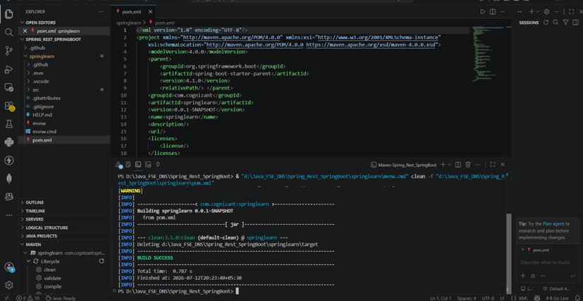

Exercise 2: Spring Core – Load Country from Spring Configuration XML
Topic: Integrating Spring Core XML configurations into a Spring Boot application .

Full country.xml:
XML
<?xml version="1.0" encoding="UTF-8"?><beans xmlns="http://www.springframework.org/schema/beans"
xmlns:xsi="http://www.w3.org/2001/XMLSchema-instance"
xsi:schemaLocation="http://www.springframework.org/schema/beans http://www.springframework.org/schema/beans/spring-beans.xsd">

<bean id="in" class="com.cognizant.springlearn.Country">
<property name="code" value="IN"/>
<property name="name" value="India"/>
</bean></beans>
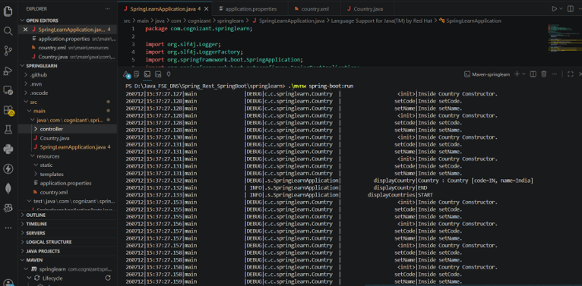

Exercise 3: Hello World RESTful Web Service
Topic: Creating a basic @RestController to handle HTTP GET requests .

Full HelloController.java:
Java
package com.cognizant.springlearn.controller;
import org.springframework.web.bind.annotation.RequestMapping;import org.springframework.web.bind.annotation.RestController;
@RestControllerpublic class HelloController {
@RequestMapping("/hello")
public String sayHello() {
return "Hello World!!";
}
}


Exercise 4: REST - Country Web Service
Topic: Mapping business objects to JSON responses .

Full CountryController.java (Partial snippet for /country):
Java
@RequestMapping("/country")public Country getCountryIndia() {
ApplicationContext context = new ClassPathXmlApplicationContext("country.xml");
return context.getBean("in", Country.class);
}
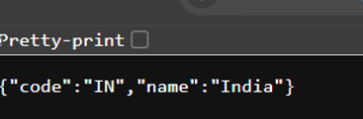

Exercise 5: REST - Get country based on country code
Topic: Implementing dynamic path variables and custom exception handling .

Full CountryService.java method:
Java
public Country getCountry(String code) {
ApplicationContext context = new ClassPathXmlApplicationContext("country.xml");
ArrayList<Country> countries = context.getBean("countryList", ArrayList.class);
for (Country country : countries) {
if (country.getCode().equalsIgnoreCase(code)) {
return country;
}
}
throw new CountryNotFoundException();
}
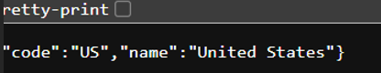

Exercise 6: Create authentication service that returns JWT
Topic: Implementing stateless security by generating and validating JSON Web Tokens .

Full AuthenticationController.java:
Java
package com.cognizant.springlearn.controller;
import io.jsonwebtoken.Jwts;import io.jsonwebtoken.SignatureAlgorithm;import org.springframework.web.bind.annotation.*;import java.util.*;
@RestControllerpublic class AuthenticationController {

@GetMapping("/authenticate")
public Map<String, String> authenticate(@RequestHeader("Authorization") String authHeader) {
String user = getUser(authHeader);
String token = Jwts.builder()
.setSubject(user)
.setIssuedAt(new Date())
.setExpiration(new Date(System.currentTimeMillis() + 1200000))
.signWith(SignatureAlgorithm.HS256, "secretkey")
.compact();

Map<String, String> map = new HashMap<>();
map.put("token", token);
return map;
}

private String getUser(String authHeader) {
String encoded = authHeader.substring(6);
String decoded = new String(Base64.getDecoder().decode(encoded));
return decoded.substring(0, decoded.indexOf(':'));
}
}
